**A PROJECT REPORT**

**ON**

**“HEALTHY EATING EDUCATION”**

SUBMITTED BY:

**Miss.Urhe komal Manjabapu (2124UCEF1005)**

SUBJECT:

**CORE C++**

**PROGRAMMING**

Under the guidance of

**Miss. Ishwari Tirse**



**Department of Computer Science and Engineering Sanjivani Rural Education Society’s** **SANJIVANI UNIVERSITY**

**KOPARGAON – 423603, DIST : AHMEDNAGAR**

**2024-2025**

# INDEX

|  |  |  |
| --- | --- | --- |
| **SR. NO** | **CONTENT** | **PAGE NO.** |
| **1.** | **INTRODUCTION** | **2** |
| **2.** | **CODE** | **3** |
| **3.** | **OUTPUT** | **5** |
| **4.** | **CONCLUSION** | **6** |

**INTRODUCTION**

In an era where dietary choices significantly impact health and well-being, promoting healthy eating habits among children has become essential. The Healthy Eating Education Program aims to empower young individuals with the knowledge and skills necessary to make informed food choices. With rising rates of childhood obesity and related health issues, this program addresses the urgent need for comprehensive nutrition education in schools.

This initiative will combine hands-on cooking classes, interactive workshops, and engaging activities to teach children about balanced diets, the benefits of whole foods, and the importance of physical activity. By fostering an early appreciation for nutrition, the program seeks to cultivate lifelong healthy habits, enhance academic performance, and improve overall quality of life.

# CODE

#include <iostream>

#include <vector>

#include <string>

using namespace std;

class HealthyEating {

public:

void displayTips() {

cout << "Healthy Eating Tips:\n";

for (const auto& tip : tips) {

cout << "- " << tip << endl;

}

}

void quiz() {

int score = 0;

string answer;

cout << "Quiz: What is a healthy source of protein?\n";

cout << "A) Chicken\nB) Candy\nC) Soda\n";

cout << "Your answer: ";

cin >> answer;

if (answer == "A" || answer == "a") {

score++;

cout << "Correct!\n";

} else {

cout << "Incorrect. The correct answer is A) Chicken.\n";

}

cout << "Your score: " << score << "/1\n";

}

void suggestMeal() {

cout << "Suggested Healthy Meal:\n";

cout << "Grilled chicken with quinoa and steamed broccoli.\n";

}

private:

vector<string> tips = {

"Eat a variety of foods.",

"Focus on fruits and vegetables.",

"Choose whole grains over refined grains.",

"Limit sugar and saturated fat intake.",

"Stay hydrated with water."

};

};

int main() {

HealthyEating education;

int choice;

do {

cout << "\nHealthy Eating Education Tool\n";

cout << "1. Display Tips\n";

cout << "2. Take Quiz\n";

cout << "3. Get Meal Suggestion\n";

cout << "4. Exit\n";

cout << "Choose an option: ";

cin >> choice;

switch (choice) {

case 1:

education.displayTips();

break;

case 2:

education.quiz();

break;

case 3:

education.suggestMeal();

break;

case 4:

cout << "Thank you for using the Healthy Eating Education Tool!\n";

break;

default:

cout << "Invalid option. Please try again.\n";

}

} while (choice != 4);

return 0;

}

# OUTPUT

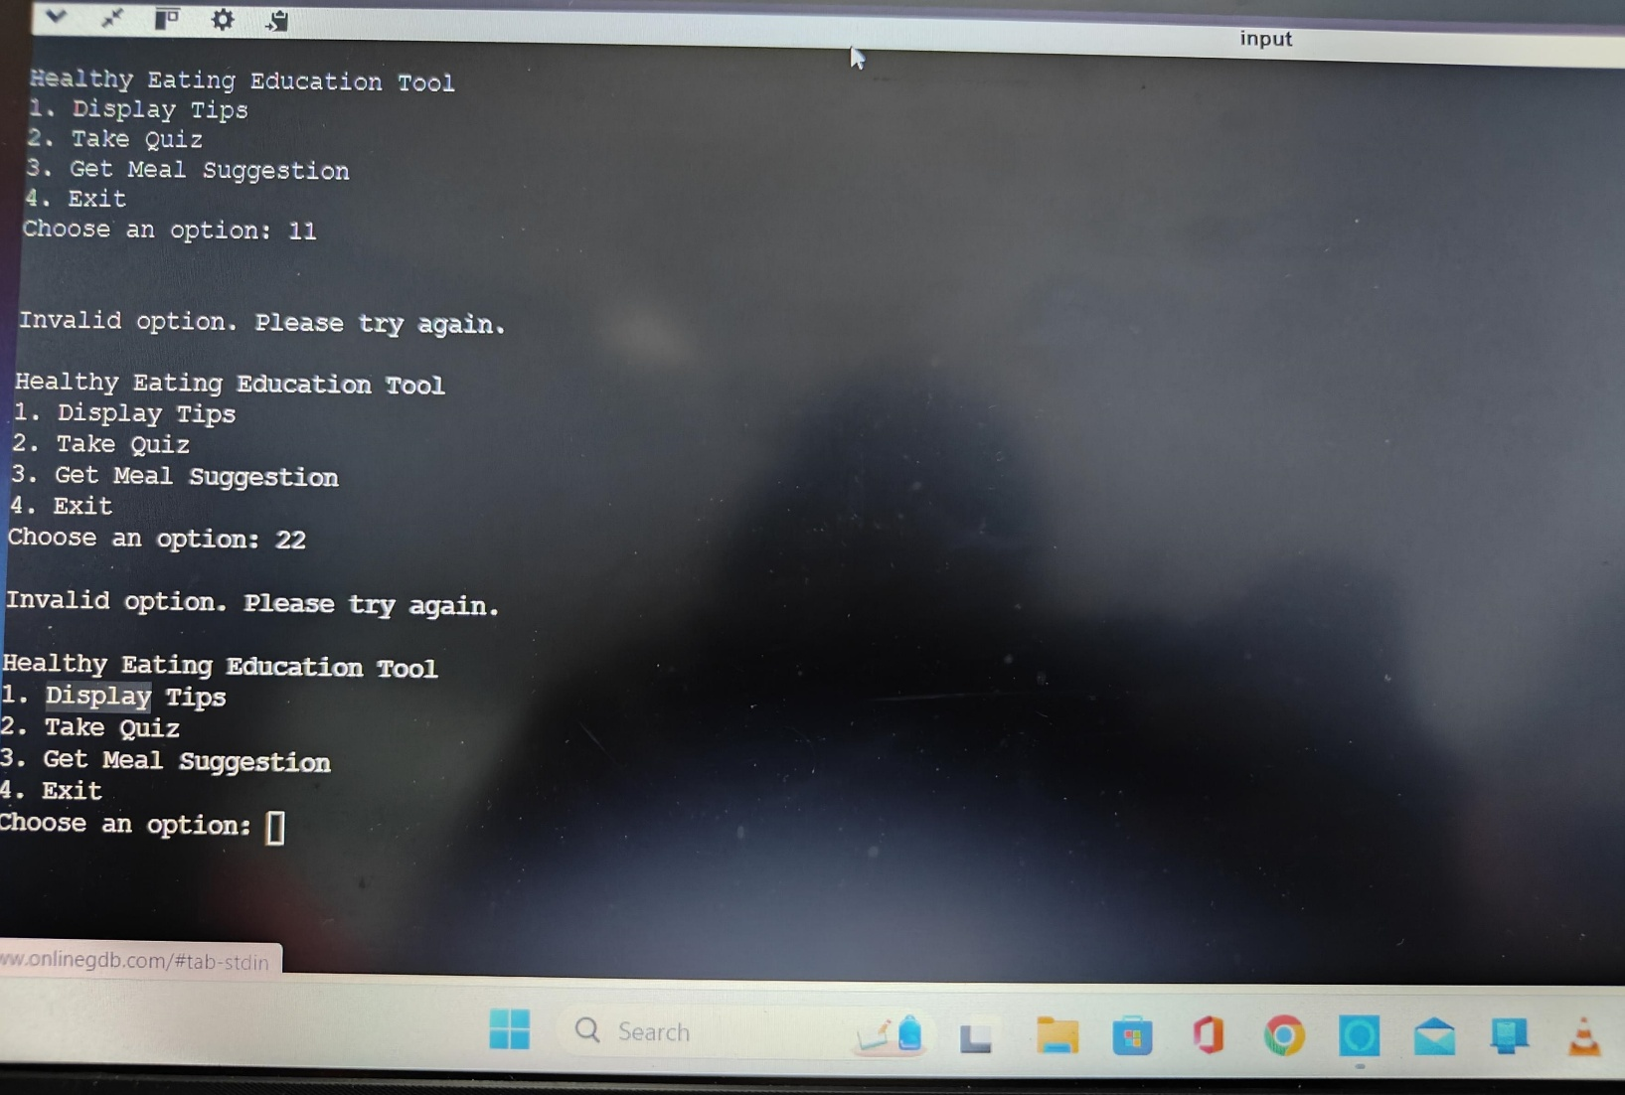

**CONCLUSION**

The Healthy Eating Education Program is a vital initiative aimed at addressing the pressing need for nutrition education among children. By providing engaging, hands-on learning experiences, the program empowers young individuals to make informed dietary choices that promote lifelong health and well-being.

Through interactive workshops and cooking classes, participants gain practical skills and knowledge about balanced nutrition, fostering a deeper appreciation for healthy eating. The collaboration with parents, educators, and health organizations further strengthens community involvement and support, creating a holistic approach to health education.